Basic AND, OR & NOT LOGIC GATES

OBJECTIVE:
- To investigate the behavior of the OR gate using IC & Transistor.
- To investigate the behavior of the AND gate using IC & Transistor.
- To investigate the behavior of the NOT gate using IC & Transistor.

THEORY:
In general logic circuits have one or more inputs and only one output. The circuits respond to various input combinations and a truth table shows this relationship between circuits input combinations and its output. The truth table for a particular circuit explains how the circuit behaves under normal conditions. Familiarization with a logic circuit’s truth table is essential to the technologist or technician before he or she can design with or troubleshoot the circuit.
In this experiment three logic circuits are covered: the OR, AND & NOT gates.

The OR operation can be summarized as follows:
- When any input is 1, the output is also 1.
- When all inputs are 0, the output is also 0.

The AND operation can be summarized similarly:
- When any input is 0, the output is also 0.
- When any input is 1, the output is also 1.

Finally, the NOT operation is said to be complementary.
- If the input is 0, the output is 1.
- If the input is 1, the output is 0.

You should recall that the logic levels 0 and 1, have voltage assignments. For TTL circuits a logic 0 can be anywhere from 0 V to +0.8 V, and a logic 1 is in the range of +2.0 V to +5.0.

EQUIPMENT / REQUIREMENT:
- 7411 IC AND gate
- 7432 IC OR gate
- 7404 IC NOT gate
- 2 LEDs or Logic Probe
- 6 NPN Transistor
- Breadboard
- 0-5 Volt DC Power Supply

PROCEDURE:
Figure 1.1 shows logic symbols of AND, OR and NOT gates. Figure 1.2 shows the layouts of AND gate IC (7411), OR gate IC (7432) and NOT gate IC (7404). The pin configuration is also given in the layouts. Construct the circuits with the help of these layouts. Pin no 7 and pin no 14 of each IC is ground and VCC respectively. Apply different inputs and observe the outputs and then compute the truth tables 1.1, 1.2 and 1.3.

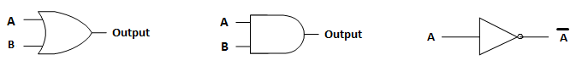
(a) Symbol of OR gate (b) Symbol of AND gate (c) Symbol of NOT gate

Fig 1.1

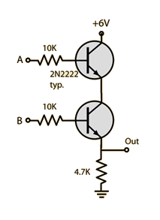
Internal Circuits of AND, OR, NOT Gate using Transistor:
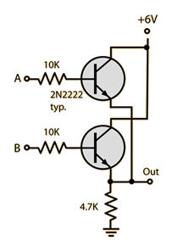
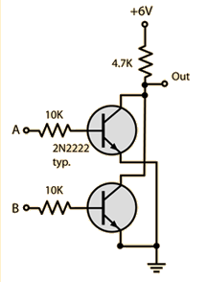

(a) AND gate (b) NOT gate (c) OR gate

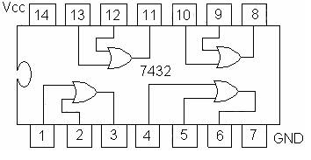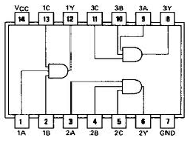
(a) 7432 quad 2-input OR gate IC (b) 7411 3 input AND gate

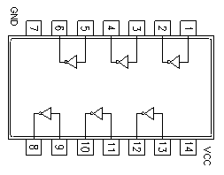
(c) 7404 (Hex Inverter) NOT gate IC

Figure 1.2:

OBSERVATION TABLE:

A | B | Q=A+B
0 | 0 | 0
0 | 1 | 1
1 | 0 | 1
1 | 1 | 1
Table 1.1

A | B | Q=A*B
0 | 0 | 0
0 | 1 | 0
1 | 0 | 0
1 | 1 | 1
Table 1.2

A | A’
0 | 1
1 | 0
Table 1.3

QUESTIONS / RESULTS:
- The output of an OR gate is LOW only when all the input is LOW.
- The output of an AND gate is LOW whenever any input is LOW.
- If an OR gate input were accidentally shorted to VCC, the output of the gate would always be______ no matter what level the other input level might be.
- A High Voltage (5volt) stood for a high output.

Addition Task to be performed:
- (AB+CD)
- (A+B.C+D)

Task 1: AB+CD

A | B | C | D | AB | CD | AB+CD
0 | 0 | 0 | 0 | 0 | 0 | 0
0 | 0 | 0 | 1 | 0 | 0 | 0
0 | 0 | 1 | 0 | 0 | 0 | 0
0 | 0 | 1 | 1 | 0 | 1 | 1
0 | 1 | 0 | 0 | 0 | 0 | 0
0 | 1 | 0 | 1 | 0 | 0 | 0
0 | 1 | 1 | 0 | 0 | 0 | 0
0 | 1 | 1 | 1 | 0 | 1 | 1
1 | 0 | 0 | 0 | 0 | 0 | 0
1 | 0 | 0 | 1 | 0 | 0 | 0
1 | 0 | 1 | 0 | 0 | 0 | 0
1 | 0 | 1 | 1 | 0 | 1 | 1
1 | 1 | 0 | 0 | 1 | 0 | 1
1 | 1 | 0 | 1 | 1 | 0 | 1
1 | 1 | 1 | 0 | 1 | 0 | 1
1 | 1 | 1 | 1 | 1 | 1 | 1

Task 2: A+B.C+D

A | B | C | D | A+B | C+D | A+B.C+D
0 | 0 | 0 | 0 | 0 | 0 | 0
0 | 0 | 0 | 1 | 0 | 1 | 0
0 | 0 | 1 | 0 | 0 | 1 | 0
0 | 0 | 1 | 1 | 0 | 1 | 0
0 | 1 | 0 | 0 | 1 | 0 | 0
0 | 1 | 0 | 1 | 1 | 1 | 1
0 | 1 | 1 | 0 | 1 | 1 | 1
0 | 1 | 1 | 1 | 1 | 1 | 1
1 | 0 | 0 | 0 | 1 | 0 | 0
1 | 0 | 0 | 1 | 1 | 1 | 1
1 | 0 | 1 | 0 | 1 | 1 | 1
1 | 0 | 1 | 1 | 1 | 1 | 1
1 | 1 | 0 | 0 | 1 | 0 | 0
1 | 1 | 0 | 1 | 1 | 1 | 1
1 | 1 | 1 | 0 | 1 | 1 | 1
1 | 1 | 1 | 1 | 1 | 1 | 1

CONCLUSION:

